~AT HOME WORSHIP~

13th September 2020

Preparation: Take a moment to be still and place yourself in God’s hands. Remember those who will also be worshipping with us and even though we cannot see them, we hold them to God.
Lord God, as we gather in your house, we thank you for your presence, here with us. Thank you, Lord, that each one of us is unique, yet we share a common bond in you. We come together as one body, but we all learn and experience things in different ways. We thank you for your amazing word that gives us so many pictures of your kingdom. Something for everyone, something to feed our hearts and minds. Be with us, Lord, and bless us richly as we call upon your name. Amen.

Hymn:
Jesus, Be the Centre
https://youtu.be/EG-l1kK-BpU

Opening Prayer
God of all, through all time and in all places, in each circumstance and season,
You call us together in this place and welcome us with open arms as your beloved children.
Each one of us is precious to you and called by you.
In this time of great change and uncertainty, you are unchanging and ever faithful.
Through this time together, let us feel you speaking to us, leading us, teaching us,
Filling us with your spirit and strengthening us for the journey ahead. Amen

Prayer for the Day
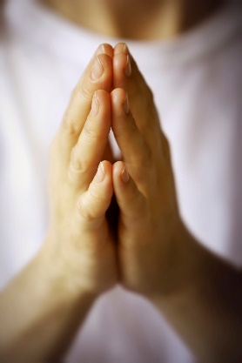
God of all grace and compassion, whose ways are perfect, whose words give us life, whose love seeks to draw us together in harmony to build Your heavenly kingdom; May we walk in truth and grace day by day in our teaching and learning in our living in community in the building up of one another.
Through Jesus Christ our Lord,
Amen.

Saying Sorry
Forgiving God,
we thank you for forgiving us when we say sorry to you:
again, again, and for ever.
Please show us how to be ready to say sorry to you,
and to each other:
again, again, and for ever.
Please teach us more about your wonderful forgiving love:
again, again, and for ever.
Amen.

BIBLE READING
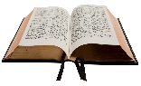

Exodus 14:19-31. From The Message
¹⁹⁻²⁰ The angel of God that had been leading the camp of Israel now shifted and got behind them. And the Pillar of Cloud that had been in front also shifted to the rear. The Cloud was now between the camp of Egypt and the camp of Israel. The Cloud enshrouded one camp in darkness and flooded the other with light. The two camps didn’t come near each other all night.
²¹ Then Moses stretched out his hand over the sea and God, with a terrific east wind all night long, made the sea go back. He made the sea dry ground. The seawaters split.
²²⁻²⁵ The Israelites walked through the sea on dry ground with the waters a wall to the right and to the left. The Egyptians came after them in full pursuit, every horse and chariot and driver of Pharaoh racing into the middle of the sea. It was now the morning watch. God looked down from the Pillar of Fire and Cloud on the Egyptian army and threw them into a panic. He clogged the wheels of their chariots; they were stuck in the mud.
The Egyptians said, “Run from Israel! God is fighting on their side and against Egypt!”
²⁶ God said to Moses, “Stretch out your hand over the sea and the waters will come back over the Egyptians, over their chariots, over their horsemen.”
²⁷⁻²⁸ Moses stretched his hand out over the sea: As the day broke and the Egyptians were running, the sea returned to its place as before. God dumped the Egyptians in the middle of the sea. The waters returned, drowning the chariots and riders of Pharaoh’s army that had chased after Israel into the sea. Not one of them survived.
²⁹⁻³¹ But the Israelites walked right through the middle of the sea on dry ground, the waters forming a wall to the right and to the left. God delivered Israel that day from the oppression of the Egyptians. And Israel looked at the Egyptian dead, washed up on the shore of the sea, and realized the tremendous power that God brought against the Egyptians. The people were in reverent awe before God and trusted in God and his servant Moses.

Hymn: One more step along the world I go
https://youtu.be/8wWRaP5xbow

REFLECTION TIME

Reflection by Angela
Our passage today describes the miraculous parting the Red Sea to save the Israelites from the Egyptian army which was pursuing them. It is a dramatic and astounding miracle which we undoubtedly remember from childhood. I wonder when we think of this passage, who do we credit with the drawing back of the water – is it Moses who stretches his hand over the water? Or is it God? All the while that Moses was leading the Israelites in their exile in the desert, Moses was intimately guided and instructed by God in what to do. The Israelites were very frightened by the approaching army and since there was no way out, they assumed a certain death. But God instructed Moses to take his staff and stretch his hand over the water to provide this unimagined escape route. The miracle is a display of God’s immense power which takes place by the cooperation of Moses with God. It required Moses’ obedience and trust, which is remarkable when we think of what he is being asked to do. Moses is learning from God and learning to trust him with his life and the lives of the Israelites. We see at the end of the reading that witnessing this incredible display of power over the elements of nature teaches the Israelites to trust God and Moses, and fills them with reverent awe. God breaks through in a time of great upheaval.
On Education Sunday we think about learning, and specifically this year we are asking how we can be peoples of learning and trust, when all about us is change and upheaval. If I think back to times in my life of great change, such as moving to live in another country and becoming parents, to be honest they were times of doubt and apprehension amongst the hope. But they became times of great learning; finding reserves of resilience and gaining confidence, learning new ways of living and depending on others in those journeys. What comes to mind when you think of a time of great change for you?
Education is all about change. Learning new knowledge and skills; learning how to be our best selves (and blessed selves!), and learning to be curious about our world. We expect to change for the better by our education. And yet, when our lives change in ways we did not anticipate and in particular if the changes are unpleasant and alarming, we may not have these expectations. It is easy to ‘pull down the hatches’ and wait for things to pass. Naturally. However, we might miss opportunities to learn through these changes too; to actively seek to better ourselves and to learn how to play a part in creating a better world. Romans 8:28 tells us “²⁸ And we know that in all things God works for the good of those who love him, who have been called according to his purpose.” As Christians we look to God to teach us in times of change, to better us, and to build up our trust in him. This is not always an easy path. The passage here reminds us to also be expectant of God in bringing help. God’s grace is greater than we can expect or understand. How amazing is that! We pray and pray again. Pray for more revelation of God to rescue us. And we trust.
For children and young people, the pandemic and lockdown have been particularly challenging, not least because it has been a much greater proportion of their life than for us older folks. They faced months of school or college closure and disrupted education. Plus an added stress is the poor understanding of how the virus spreads and affects the body, and the frequently changing regulations to try to restrict it. In education and in life, we are more comfortable when things are certain and reliable. As a science teacher though, I enjoy opening student’s eyes to the beauty of mystery, the need to question results and the journey of learning that research scientists must go on. Many eminent scientists find that the more they know, the more they realise they don’t know, and instead of unsettling them this can bring them to a deeper faith. It can deepen their trust in a God who creates such wonder and complexity. In conversations with young people, we are all called to encourage their curiosity and for them to discover wider horizons which can feed their faith in God.
How do we help them and ourselves to cope with this current upheaval of normal life and to learn more of God? We remind ourselves that Jesus is at the centre of all things. He is our centre and our refuge. Jesus is the light in the darkness. The Israelites were led in the desert by two pillars; a pillar of cloud in the day, and a pillar of fire lighting the way in the dark. God gave the pillars so that they knew of his constant presence. The reading told us that during the night before the miracle, the camp of the Israelites was flooded with light while the other camp was in darkness. We too can trust that God is always with us, and lighting our way. Hold that image that our ‘camp’ is flooded with the light of God. It is fine to acknowledge our struggles but we choose to trust and embrace the chance to be a learning people in time of change. For ourselves, our children and young people, and in education, there is both hope and opportunity.

Question to ponder or discuss with others: How have you experienced God helping you, speaking to you, guiding you through this time?

Reflection for children and young people (or people of all ages )

In the bible passage we read about the miracle of the Red Sea being pulled back to make a pathway for the Israelites to save them from the Egyptian army. The army was following in order to destroy them. It was a terrifying time for the Israelites as there seemed to be no way out for them and they faced death. Sometimes people face very frightening situations or challenges, and Jesus wants us to know that he is with us.

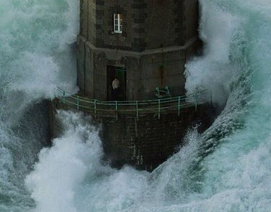
Reflect upon this image of a very stormy sea battering a light house.
Then think about how you would answer these questions:

- What is happening around the lighthouse in this image? How might this be similar to some of the challenges you/ we/ the world are experiencing right now?
- What is the response of the individual in this image? How are you responding to the challenges we have just mentioned?

In the song ‘My Lighthouse’ by Rend Collective, we are reminded that Jesus is our lighthouse, shining in the darkness and safely carrying us. Jesus is our peace in a troubled sea.

Family Song: My Lighthouse – this version is bright, colourful and has hand actions to join in with!
https://youtu.be/JeJvKkBV6rY

Time for Prayer -A prayer from our School’s worker Gayle Bryon
Today we pray for all our local schools using the image of the tree.
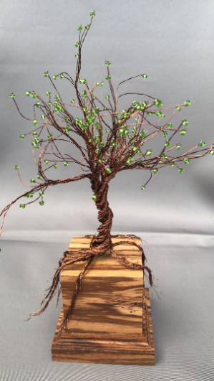
The tree is a wonderful image of beauty, journey, and learning.
Imagine the faintly greening tender child sapling, the radiant blossoming teenager,
the abundant and fruitful young adult, and the breath-taking stature and elegance of a mature tree. Trees are so important, they balance the air we breathe, the land from erosion, they provide shelter for creatures, they provide food, and inspiration for poems, music, and art. What better image to use when thinking about our schools and the work they do to nurture the young minds of our community than that of a tree.
As part of Education Sunday each school will be given a gift of a beautiful hand-crafted tree as in the picture to thank them for the love and care they show the children of our community.
The image of the tree can also speak to us of God. Patience...protection...wisdom...creation...
Take some time to look at trees in your garden or when you out for a walk.
Sit or stand by a tree if you are able or use the tree image to take time to talk to God
and to pray for our schools, our Churches, and our community. Pray that with our roots
deeply embedded in God’s love we can all grow into beautiful trees. As people of God,
we can be a place of shelter, a source of encouragement and a symbol of faith in our
community.

Dear God,
We pray for our local schools and name them before you now,
Brook Field, Shaw Ridge, Tregoze, Hazlewood, Peatmoor, Westlea, Millbrook, Oliver Tomkins and Lydiard Park Academy.
We pray for those in leadership roles, give them strength and wisdom.
We pray for those in support roles, give them calmness and compassion.
We pray for parents, give them patience and peace of mind.
And we pray for all the children, give them a thirst for learning and joy in friendships.
Bless our school communities through these challenging times.
We pray that the children of our community grow roots in your love and blossom into beautiful trees.We are all a learning people in a time of change. Guide each, and every one of us.
Amen.

​Lord’s Prayer
Our Father in heaven,
Hallowed be your name,
Your kingdom come,
Your will be done
On earth as in heaven.
Give us today our daily bread
Forgive us our sins
As we forgive those who sin against us
Lead us not into temptation
But deliver us from evil.
For the kingdom, the power,
And the glory are yours
Now and for ever.
Amen.

Praise Hymn: Teach me to dance https://youtu.be/aDyFgNX4es8

Closing Prayer
God did not leave His people alone in the wilderness,
he stayed with them and led them on.
Jesus said, Lo I am with you always, even to the end of the age.
We are a learning people in a time of change. May the God who calls us, lead us on. Amen

Blessing
May the peace of the Lord Christ go with you,
wherever He may send you.
May He guide you through the wilderness,
protect you through the storm.
May He bring you home rejoicing
at the wonders He has shown you.
May He bring you home rejoicing
once again into our doors.
In the name of the Father, and of the Son, and of the Holy Spirit. Amen

