Sunday Worship at Home
Sunday 4th October – Season of Creation:Climate Sunday
Prepared by Angela Mak and Pete Rogers

Preparation
Take a moment to sit and be still. Breathe slowly and deeply. Allow God’s presence to be felt as you bring yourself closer to him. Remember all those who will be worshipping and praying in their own homes and know that we are together in fellowship and spirit.

Prayers for the Day
Gracious God, you call us to fullness of life:
Deliver us from unbelief
And banish our anxieties with the liberating love of Jesus Christ our Lord Amen

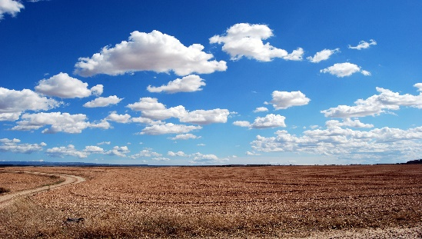

Opening worship
Hymn
1 For the beauty of the earth,
for the glory of the skies,
for the love which from our birth
over and around us lies.
Refrain:
Christ, our Lord, to you we raise
this, our hymn of grateful praise.
2 For the wonder of each hour
of the day and of the night,
hill and vale and tree and flower,
sun and moon and stars of light, [Refrain ]
3 For the joy of human love,
brother, sister, parent, child,
friends on earth, and friends above,
for all gentle thoughts and mild, [Refrain]
4 For yourself, best gift divine,
to the world so freely given,
agent of God's grand design:
peace on earth and joy in heaven. [Refrain]
Psalter Hymnal, 1987. Author‎: ‎Folliott Sandford Pierpoint‎ (1864)

Saying Sorry
In a moment of quiet, hold up to God the thoughts, words and actions, for which you need to ask forgiveness.
(by Rev’d Any Braunston is a URC minister.)
O God of freedom

You led your people of old
with cloud by day and fire by night.
You parted the sea with your breath,
and saved Your people from oppression.
Free us, O God, in our own age.
From
…indifference in the face of poverty,
…ignorance in the face of fact,
…disbelief in the face of evidence before our very eyes,
deliver us good Lord that we may allow the earth to heal.

Lord of the living and Lord of the dead, we are conscious of our sin.
We are weak in faith, quarrelsome in nature and there is no health in us.

When we deny the science of climate change, enlighten us.
When we continue to pollute our earth, convict us.
When we exploit Creation, chastise us.
When we fail to cherish the Earth, our fragile home, change us.
When we fail to love the poor and oppressed, forgive us.

Give us time, O God,
even at this late hour,
to change, to turn away from destruction and back to you.

pause

God is the fount of all mercy and through the life, death, and new life of Jesus Christ, has shown us how to live calling us to renewed action and commitment.
Through the ministry of the Church may we receive pardon, peace, and wisdom,
that we may use your time well,
be filled with grace, and help to renew the earth. AMEN.

1st Reading
Psalm 104 - (modified). Read it aloud – perhaps two can take turns to read
One Bless the Lord, O my Soul!
Together All creatures look to you to give them their food at the proper time. When you open your hand, they are satisfied with good things.
Two You have made the moon to mark the seasons; the sun knows its time for setting. You make darkness, and it is night, when all the animals of the forest come creeping out.
Together All creatures look to you to give them their food at the proper time. When you open your hand, they are satisfied with good things.
One The lions roar for their prey and seek their food from God; The sun rises, and they steal away; they return and lie down in their dens. Then people go out to their work, to their labor until evening.
Together All creatures look to you to give them their food at the proper time. When you open your hand, they are satisfied with good things.
Two From your lofty abode you water the mountains; You make springs gush forth in the valleys; they flow between the hills, giving drink to every wild animal;
Together All creatures look to you to give them their food at the proper time. When you open your hand, they are satisfied with good things.
One You cause the grass to grow for the cattle, and plants for people to use, to bring forth food from the Earth, wine to gladden the human heart, oil to make the face shine, and bread to strengthen the human heart.
Together All creatures look to you to give them their food at the proper time. When you open your hand, they are satisfied with good things.
Two The Earth is satisfied with the fruit of your work.
Together All creatures look to you to give them their food at the proper time. When you open your hand, they are satisfied with good things.
May the glory of the Lord endure forever!

2nd Reading
Ezekiel 33:7-11
⁷ “Son of man, I have made you a watchman for the people of Israel; so hear the word I speak and give them warning from me. ⁸ When I say to the wicked, ‘You wicked person, you will surely die,’ and you do not speak out to dissuade them from their ways, that wicked person will die for their sin, and I will hold you accountable for their blood. ⁹ But if you do warn the wicked person to turn from their ways and they do not do so, they will die for their sin, though you yourself will be saved.¹⁰ “Son of man, say to the Israelites, ‘This is what you are saying: “Our offenses and sins weigh us down, and we are wasting away because of them. How then can we live?”’ ¹¹ Say to them, ‘As surely as I live, declares the Sovereign Lord, I take no pleasure in the death of the wicked, but rather that they turn from their ways and live. Turn! Turn from your evil ways! Why will you die, people of Israel?’
Thanks be to God

Short Reflection by Angela Mak
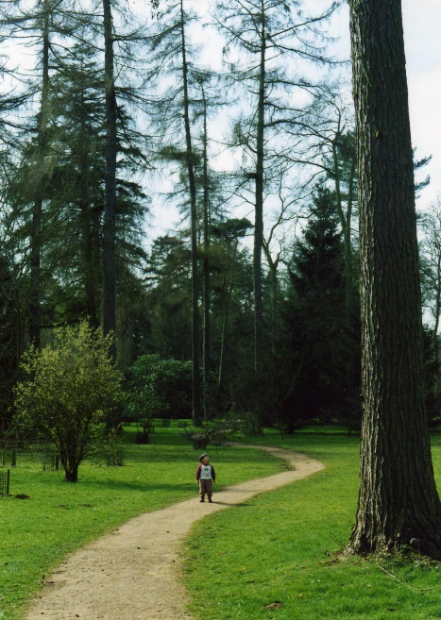
Today is October 4th, the feast day of St Francis and the last day in the Season of Creation. Many traditions view St. Francis as an inspiration and guide for those who protect creation. Francis of Assisi expressed his love for God through his love for and care of God’s creation and in his "Canticle of the Creatures," he reveals how all creation is connected in one family under God's loving care. ‘Praised be You, my Lord, through Sister Mother Earth, who sustains us and governs us and who produces varied fruits with coloured flowers and herbs.‘ Psalm 104 celebrates the immensity and detail of God’s creation, and emphasises the interdependence of living things with each other and their environments. “The Earth is satisfied with the fruit of your work.” In ecology, we know how a change in one organism cascades across the ecosystem because of this interdependence. Sometimes measures are put in to place for conservation of an ecosystem such as a woodland which is becoming damaged. Rather than keeping things as they are, conservation is a dynamic process of management of the ecosystem. On climate Sunday we think about the shocking damage that is happening to our world as a result of man’s activities which disrupt the earth’s atmosphere and climate. As scientists tell us, when we damage one part the consequences are far lasting. What is our response to the damage and how do we ‘manage’ our world and resources? As the climate warms, severe weather results with devastating droughts in many of the poorer areas of the world, storms which wreak havoc, forest fires over vast areas and more regular flooding. Humans have led to climate change by: over use of fossil fuels releasing vast amounts of carbon dioxide in to the atmosphere where it traps the sun’s heat, deforestation removing the sinks of carbon which would have been held in the trees, using vast areas of land which could have grown plant crops/trees for methane-producing cattle farming. Methane is another culprit about 28 times more powerful than carbon dioxide at warming the Earth. Climate change results in thousands or hundreds of thousands of deaths a year, particularly affecting the poor and elderly. Plus untold loss of other species.

How does God feel when he sees this suffering, when he sees his wonderful tapestry of creation unravelling in parts? It is absolutely right that we engage with this issue; The Church of England states that responding to climate change is an essential part of our responsibility to safeguard God’s creation. Our own Diocese of Bristol was the first diocese to declare a Climate Emergency, with focus on significantly reducing our carbon footprint. The Pope, who chose to be named after St Francis, is a regular advocate on the essential need of Christians to protect the environment and to act to limit climate change. The facts are sobering, and we are called to repent of our role in damaging the world, large or small. We see in the Ezekiel passage that God sometimes calls people to warn others of the consequences of their action and where damage is being done. Ezekiel was a prophet appointed to be a Watchman to warn people of imminent danger. But if we look carefully, Ezekiel emphasises God’s desire for renewal and redemption. God cares much less for the punishment of the wicked than for the renewal of those who see their sin and turn towards a different journey. As Christians we receive forgiveness at the cross of Jesus in our repentance. We have opportunities to move forward positively, actively pursuing change in how we and others live to lessen the damage to the environment.

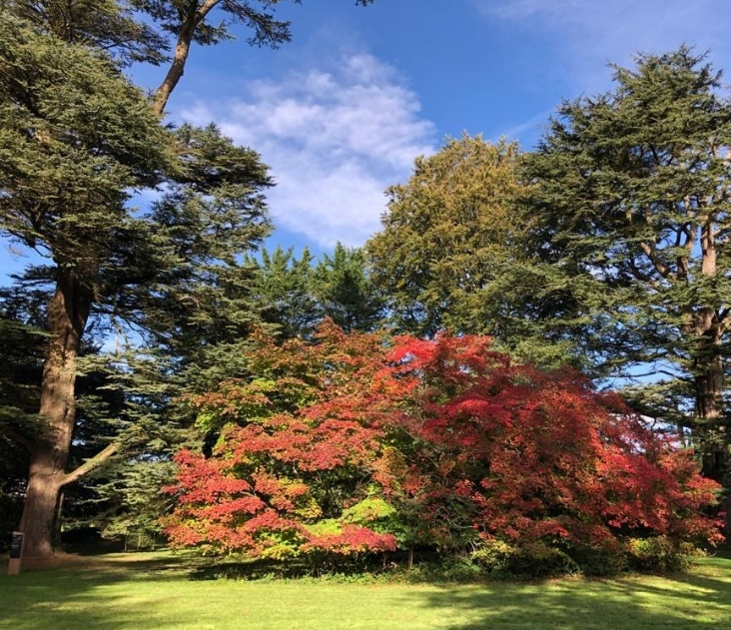

Yesterday Simon and I spent the day at Westonbirt Arboretum and marveled at the beauty and richness of the collection of ancient trees. I have always loved trees – their grandeur and yet somehow their gentleness and fragility too. Have you ever thought how astounding it is that trees (and any plants) don’t age! Unlike animals they don’t die of old age, only if conditions are extreme enough to kill them or we cut them down! There are some bristlecone pine trees and yew trees believed to be about 5000 years old – living in times of the earliest Old Testament characters!! Trees are essential to life and forests are estimated to store about 45% of all land carbon. But it is the beauty of trees and the awe that they inspire which I believe can help us in our roles of stewards of God’s creation. For thousands of years people have found being in nature produces a positive effect both on their well-being and also their sense of God and creation. It is almost impossible to dwell inwards on our struggles if we engage with a place of beauty. We are drawn to splendour and drawn to our God who creates and sustains this intricate dance of life. Taking ourselves outside allows us to restore our awe at nature and is a motivation to engage with protecting our environment.
That which we love, we celebrate
That which we love, we protect
That which we love, brings joy.
Caring for our earth is firmly rooted in the love of God and love for our neighbour. We are all dependent on each other and that is part of God’s wonderful design. As Christians we make God’s love visible when we engage with practices to protect the environment and climate, and we have the privilege of partnering him in sustaining his tapestry of life.
Jesus emphasizes the need to pursue justice and this can involve campaigning for change politically and socially. For individual lifestyle changes there are numerous websites with ideas, including the World Wildlife Fund who offer a carbon footprint calculator which I’ll link to at the end. One powerful change is to eat more plants and less meat. Switching to just one vegetarian or vegan meal a week for a year saves greenhouse gases equivalent to driving 1160 miles! And clearly lowering our use of fuel for driving or flying is a positive choice, as is buying less clothes and commodities. Rev. Kathy Galloway on the Leadership Team of the Iona Community and former head of Christian Aid Scotland talks about the freedom that can come from having less: “We may have less things but we make less waste – and we have more room for imagination, creativity, discovery. We go deeper into our spirituality. “
On this climate Sunday, let’s reflect on the wonder and beauty of the world God has given us, and dedicate ourselves anew to good stewardship and celebration of God’s gifts and providence.

Hymn Poem- One day I said sorry (listen – you will know the tune)
https://www.youtube.com/watch?v=cKA8PvX86YA
- One day I said ‘sorry’, out loud, to the Earth.
I’m sorry I trampled each day since my birth.
And burned, tarred and wasted the gifts in my hands
And passed off my greed as my Father’s Commands.
==================

- “Dear child”, said the Earth, “Since God shaped from my clay
humanity - one with my creatures that play.
There’s much of delight, as you till and protect,
and bring forth great wonders, and love and respect.
========================
- But yes, for this moment, you’re way out of line:
in selfish employ of your talents and time;
with poverty even of three billion kin
I’ve shown you already the mess we’re all in.
========================

- You’ve hurt me: I lash out, but I keep no grudge
And God who shapes all of us judges the judge.
I just want the pain and extinction to stop
I couldn’t care less now, who comes out on top!”
========================

- “Earth longs to forgive you” - a voice: was it Christ?
“When debt’s written off, shackles are sacrificed.
Forgiveness frees debtors to dance and rejoice:
Change course: choose forgiveness: know, you still have choice!

Intercessory Prayer
You could choose to pray using the prayer activities produced as a page at the end of this service or follow a preferred model of prayer for yourself.
Prayer of Intercession in Creation Time
(From Rev David Coleman, EcoChaplain with EcoCongregation Scotland.)

Let us pray with Christ:

God, who makes us with the Earth
God, who gives us to the world
God; God-with us in our struggles:

Hear us, stand with fears and needs
And walk, hold hands, advise, encourage.

for the world

What have we heard, in the news this week?
Who is in need and who should give thanks?
How far have we got, and where have we stumbled?

And what seems completely beyond us?
Listen for Earth’s voice: what is it saying?
We remember our neighbours, of whatever species
We pray for our enemies, and those we fear.
And pray for peace throughout Creation.

Hear us, stand with fears and needs
And walk, hold hands, advise, encourage.

for the church

Give thanks for the faithfulness, undergirding prayer.
Be open about continuing divisions, including local ones.
Look to a greater integration of environmental concern in our life and work.
And seek openness to the joy of deeper fellowship with all Creation

Hear us, stand with fears and needs
And walk, hold hands, advise, encourage.

for ourselves

In silence: bring to God what no one else need hear: not for God to ‘hear’ but to remind ourselves that God knows and understands.

Pray for those we pray with, acknowledging and respecting what they cannot share with us.

Look for support and perseverance, and some sustaining sign when we get things right.

Pray for ‘impatience’ - not simply to accept ‘the way things are’
And pray for peace in our heart, and the fuller joys of Christ.

Hear us, stand with fears and needs
And walk, hold hands, advise, encourage. AMEN

The Lord’s Prayer
Our Father in heaven; Hallowed be your name, Your kingdom come, Your will be done on earth as in heaven. Give us today our daily bread. Forgive us our sins as we forgive those, who sin against us. Lead us not into temptation but deliver us from evil.
For the kingdom, the power, and the glory are yours now and for ever. Amen

Worship song – Is He Worthy. Andrew Peterson at Sing! Live https://www.youtube.com/watch?v=DMWrAqMWhWs

Join in with responses – beautiful choir worship

Is all creation groaning? (It is)
Is a new creation coming? (It is)
Is the glory of the Lord to be the light within our midst?
(It is)
Is it good that we remind ourselves of this? (It is)

†
Blessing
(shared by Rev’d Any Braunston is a URC minister, working with a group pastorate South of Glasgow.)

May the One to whom every knee shall bow
and every tongue praise, enfold you in loving kindness.

May the One who was nailed to a tree for challenging the powers,
give us grace to challenge the lies of this age.

May the One who sustains Creation inspire such love in us,
that we remain unsatisfied until the Earth is healed.

And may the blessing of Almighty God,
Father, Son and Holy Spirit,
be with us and all whom we love
now and always. AMEN

†

Extra resources
- For ideas on what we can do, and includes a carbon footprint calculator
https://www.wwf.org.uk/what-can-i-do
- Video clip on Season of Creation highlights in 2017
https://www.youtube.com/watch?v=izo7sRlACa4

Suggestions for Prayer tod ay & during the week

Prayer Jars
It can be difficult at times to decide on what to pray for. Having something like a prayer jar may help.
You could put slips of paper into the jar over the course of a week, prayers for people or situations, prayers of thanks for answered prayers etc.
During the time of prayer today (and/or during the week), you could take them out (or a few) and spend time focusing on them, offering them up to God’s love, mercy and care.

Prayer Stones
The idea for using prayer stones is that they can represent people or situations.
As we are now in the Holy Habit of Making More Disciples, it may be that there is a person in particular, who you are praying for to come to know and follow Christ for themselves. Think of people you know and love. Think of people you know about through the news. Is there anyone you can think of whose lives could be transformed by knowing the overwhelming love and grace of God?
Pray for them. Pray for them every day. Pray that they might come to know God’s love for themselves. Pray that they might become a disciple of Jesus.
Choose stones, buttons or something colourful that can be kept somewhere as a prayer focus. When you look at the object, remember who or what it represents and offer a prayer to God.
Finger Labyrinth [see below]
A Labyrinth is different from a maze. There is only one path. You cannot get lost.
As you travel inwards,
- think about your life journey up until this point.
- Think of all the highs and lows. All the turning points. All the times when you have noticed God at work.
- Notice how the path turns back on itself and you pass close by to events in the past.

- How have things in your life been connected?
- Offer all of these to God.
- When you get to the centre, rest a while in
God’s presence. Just be still and attentive.

- When you are ready, slowly trace your finger back out of the labyrinth.
- Imagine you are walking outwards, back into the world, knowing God’s presence with you.
- Listen to what new things God may be calling you to now.
You could use the labyrinth to focus your prayers on the situation in the world at the moment. Start by praying for the wider world, bringing it to your own home when arriving in the centre, then moving back out to the whole world.

Take a moment of silence between each prayer to listen – you may hear the sounds of nature if you are outside, or the hum of electrical appliances inside. Breathe quietly and slowly to focus on listening to what God might be saying to you.

For Children
Use the labyrinth Pray for your friends, your family and for yourself.
- You might be able to draw your own labyrinth in chalk in the garden and walk around that, saying prayers as you change direction on the drawn path.
- Remember, if you are worried or sad about anything, tell a grown up.
- God loves you very much.

